One Book NI: Barney Norris interview
By Conor O’Neill


We’re into the second week of Libraries NI new initiative, One Book NI, which aims to: “Bring communities together by giving them a shared experience of reading. Whether in work or at home, One Book NI is all about coming together and starting conversations.”
To start that conversation Libraries NI chose Turning For Home, a book about the Boston Tapes – The Belfast Project was launched in 2001 and was designed to become an oral history of the Troubles. Former loyalist and republican paramilitaries were granted anonymity while they were living and gave candid interviews that chronicled their involvement in the Troubles – a book concentrating on the November 8th, 1987, Enniskillen bombing and its fallout.
At last I get the opportunity to interview the author, Barney Norris, covering everything including the initiative, his approach to writing, politics, book sales and the ‘golden age of story-telling’.
We start at how he came to be involved: “They chose me, as I understand it the project was thought up about a year ago and I think the people who selected Turning For Home were looking for something to start conversation, something that was provocative maybe and have points of real interest for the people of Northern Ireland.”
You’re just back from a reading tour to promote the initiative, how did you find Northern Ireland, was the last week your first time here? “No, I had visited before but this was my longest time. The book takes place in England. It is an English novel dealing with the legacies of the Troubles, among other things, as it impacted on an English family, rather than a Northern Irish novel which I couldn’t really write having never experienced the country in real depth. This last week of work was a real immersion into a country which I feel like I’m just discovering and exploring through this story both as a reader and as a tourist. We did over 700 miles in the space of a week which was an amazing immersion into the communities.”
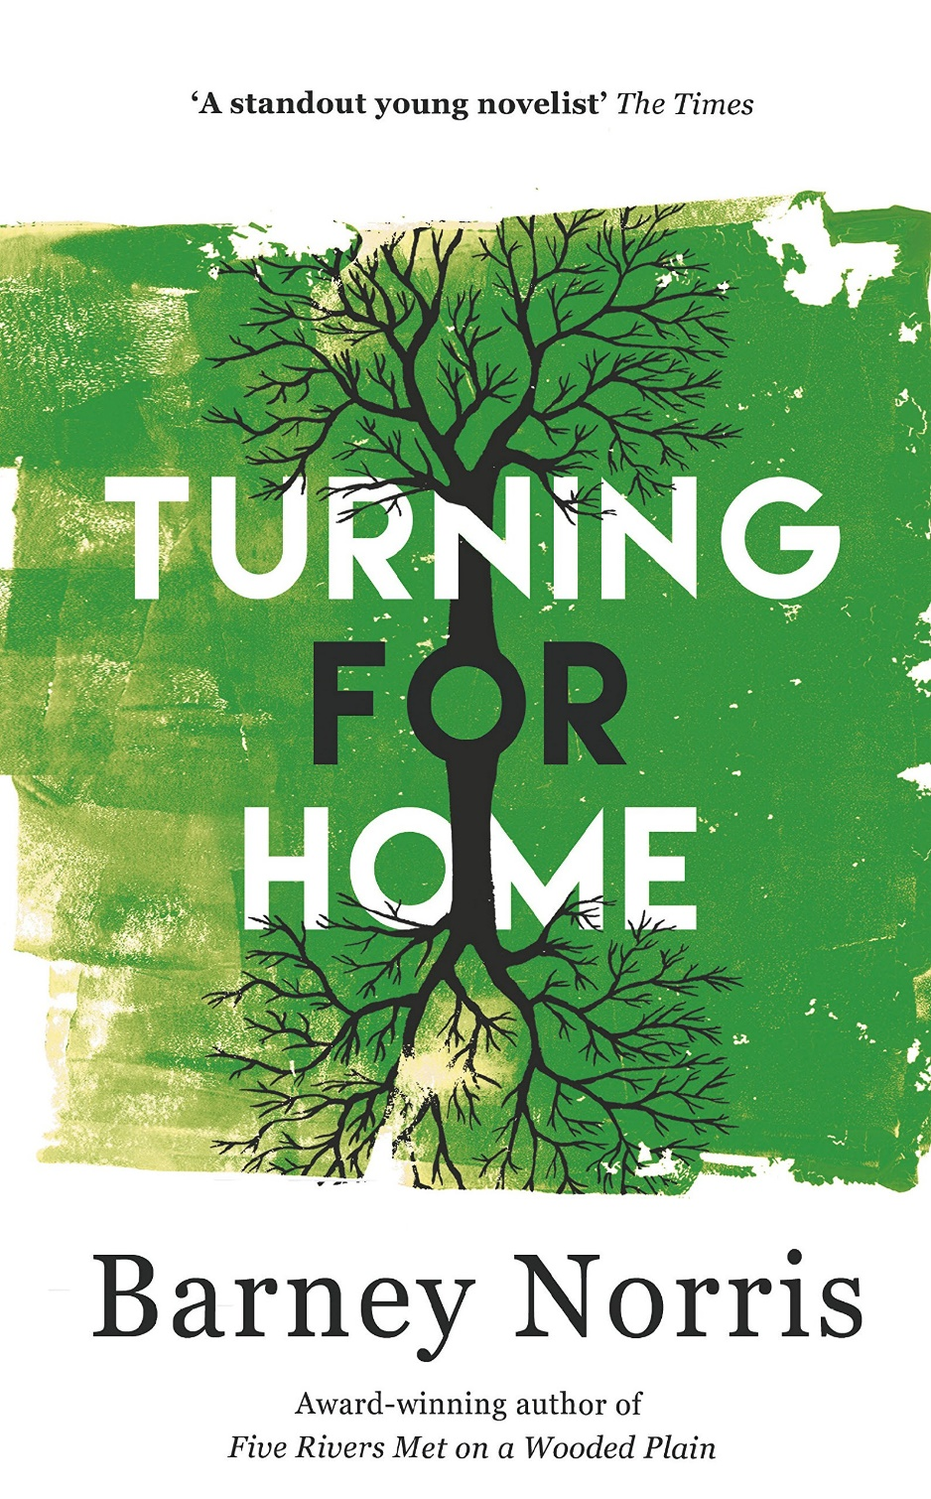
When I first read about the initiative and found out about the author being English and a relatively young writer, I did have my doubts but realised an outsider’s view point may be refreshing? Norris is quick to clarify his position on the topic: “They {The troubles} shaped the lives of everyone you’re going to meet in Northern Ireland. These conflicts might be in the past but the consequences of them continue and are lived each day by everyone in Northern Ireland. It’s not history, it is everyday life. Of course it’s around us in England as well. The English people who don’t realise the UK has been shaped and changed by them just haven’t done their homework, they’re not looking close enough.
“This was a huge world conflict, and I’m not claiming ownership for a moment, or English ownership; the conflict is Northern Irish, the people who suffered were overwhelmingly the people who were there but of course it’s a conflict that belongs to the world; it’s given so many lessons to the world since 1997 about how communities can coexist and how progress can be made. It’s also gave so many lessons before 1997 and since about communities can fall apart, how not to do things, how things can go wrong, how loss inflicts more loss and begets loss. I think what I met going round Northern Ireland was, from the audiences I spoke with, was the real clear sighted, really intelligent understanding that the identity of the person who talks about the Troubles is not as important as the fact the Troubles get talked about.
“The legacy of the conflict is actively understood and learnt from and drawn on. I think one of the big themes of the book is how you deal with the traumas of the past. Do you move on from it, or do you engage with it? You know, do we talk about amnesties? Do we talk about truth and reconciliation? What’s the route that helps us out of personal trauma, and national traumas? And the truth is that neither really works because grief is grief, trauma is trauma, pain is pain, and once it’s been inflicted people are always hurt and there is no recovering from terrible pain. In a way it will always be there buried in the past.”
I interrupt saying: “There’s a lot going on at the moment, Brexit, soft border, hard border etc. but your point that ‘the hurt has already been done’, do you think Northern Ireland should maybe adopt something like the post-apartheid South African model of the Truth and Reconciliation Commission? What do you think would be the way forward?”
Norris thinks for a moment and responds: “In truth I wouldn’t presume to suggest any particular path forward. I witnessed, as an amateur and an outsider coming into Northern Ireland, for my part, what I witnessed was a country, I met a few hundred people but let’s say I met several communities in half a dozen towns and cities, I went into a prison, I talked to people from different backgrounds, I met people with a clear understanding of the culture they were from, who were being shockingly betrayed by their politicians who don’t go to work.
“As an outsider, all I know is that I met brilliant people who deserve better representation than I think they’re getting and who are kind of being frogmarched into this tragedy, Northern Ireland voted to remain, you know, the country is being hijacked by political ambitions that have nothing to do with the history of Northern Ireland and it’s being distorted by and damaged, lives are being damaged by idiots in England. I’m sorry, I shouldn’t be being negative, I’m sure there are people who are pushing through Brexit, who are doing that for the best interest but I think the way the Northern Ireland situation is being handled with the hard border by the Conservatives is nothing short of idiocy that is ham-fisted incompetence. Then you have the situation in Stormont and you think, ‘Oh my god, people deserve better than this’. That is just an outsider’s view, I wouldn’t presume to know what to do.”
Norris started life as a playwright, Turning For Home is his second novel and quoting a line from a previous interview, I focus on the difference between writing for the stage and writing a novel before asking him to elaborate? He replies: “I that specific case we were talking about tempo. I suppose the wonderful thing about a book is that the reader has total control. As a writer you can give yourself up to explorations and tangents which in the theatre wouldn’t really be possible. I remember Michael Frayne saying, ‘In a book you can tie the hero to the train track and then go away for a couple of pages and talk about the history of rope, the history of the knot they’re tied up with and come back and the train hasn’t got any further, where as in a play you came back and hero has been run over’ and that’s the key difference in the two forms is you have time playing out differently for the audience.”
And what about characters? In Turning For Home the two main characters are Robert and Kate. Robert is an older gent while Kate is his granddaughter, different in both age and gender? Norris explains his approach: “The key for me in starting is that people are all people, the differences on the surface that make them unique make them all equally difficult to write because they’ve all done stuff you haven’t. You have to start believing that people react in the way that human beings do and there is a shared understanding in the concept of mind that unites experience. The way I differentiate would be about frames of cultural reference, vocabulary and the preoccupations of my different characters, their different hobbies, bugbears and favourites and hatreds and try to map that out and stick to it as you navigate through the story as you change from voice to voice.
“There is a core human experience that you can find in any character. Now, that doesn’t mean that it isn’t a difficult task to project yourself into a different life. We were talking earlier – Barney and presumably other/s before this interview – about what it means for a younger English writer to write for and older character who’s experienced Northern Ireland before I was born; that takes a lot of research and I talked to a lot of people, shared the manuscript with people to iron out the flaws because you responsible with the way you gender. Both women and men are human beings so there is a core humanity you have to access that by getting the facts right and understanding the way that life is different for one person whether that difference is gender, sexuality or age or race or religion or religion.”
Continuing on with our meandering change of theme, we delve into the objectives of One Book NI, one that I feel to be very ambitious, almost blindly so. On hearing my opinion, Norris says: “I think anybody setting out the ambition that every workplace talk about the same novel, of course they know they’re only going to get a certain percentage of the way toward that goal; it’s the ambition of the project that makes it so impressive. The other thing to say is that I saw the figures about the numbers of books borrowed from Libraries NI when they do a book of the month and the numbers of downloads they get. We’re talking about tens of thousands of people experiencing the same story over the case of a year when a book is really pushed and promoted, and where live events happen like the gigs I’ve just did around libraries is that they do bring people together to have conversations. The national picture is that more people consume stories now than have ever done. Of course, there is more people but proportionally more people do and that’s part of television but book sales rise as well and I think that people are actually hungry for dreams.
“Of course, you’re right, we live in an age of soundbites, 140 characters or whatever it is now and we live in a moment where attention spans are under assault by from media that seeks to pull us aside from whatever we’re doing to buy a new pair of trainers or whatever, but book sales are going up and great stories keep getting told. I actually think there’s a huge energy in the book world at the moment. Looking at festivals, looking at authors, looking at online events and the rise and rise of downloads as well as print books, it’s all a good news story and audio books as well, which continue to grow and grow.”
Again I question his optimism, making a mental note that when this interview is over to check national book sale numbers*, Norris is away again: “My experience over the past five years since my first play came to the stage is incredibly fortunate. I’ve told stories to people and people have always wanted to hear them, that may not mean anything outside of the confines of my own life, but I’ve definitely experienced audiences that have enthusiasm and intelligence you just wouldn’t believe. It’s such a privilege to talk about the stories you want to tell to the audiences because they add so much to it and personally I do believe we are in the golden age of story-telling!”
So, there it is. Barney Norris, a force of nature, both on the page and at the end of phone line.
If you want to get involved with One Book NI visit www.librariesni.org.uk
Turning For Home is available from all good book stores priced at £14.99
Book review to follow in the next few days.
*For the record, Norris is correct: Nielsen, which tracks national and international book sales, noted a significant rise in the UK, Republic of Ireland and the US in 2016. At the time of writing no figures were available for 2017
